Virtual Box Setup – Drew Blythe – Practice for Helpdesk Roles
Documented Process with steps, screenshots, and problem fixes

Downloaded VirtualBox off the website virtualbox.org
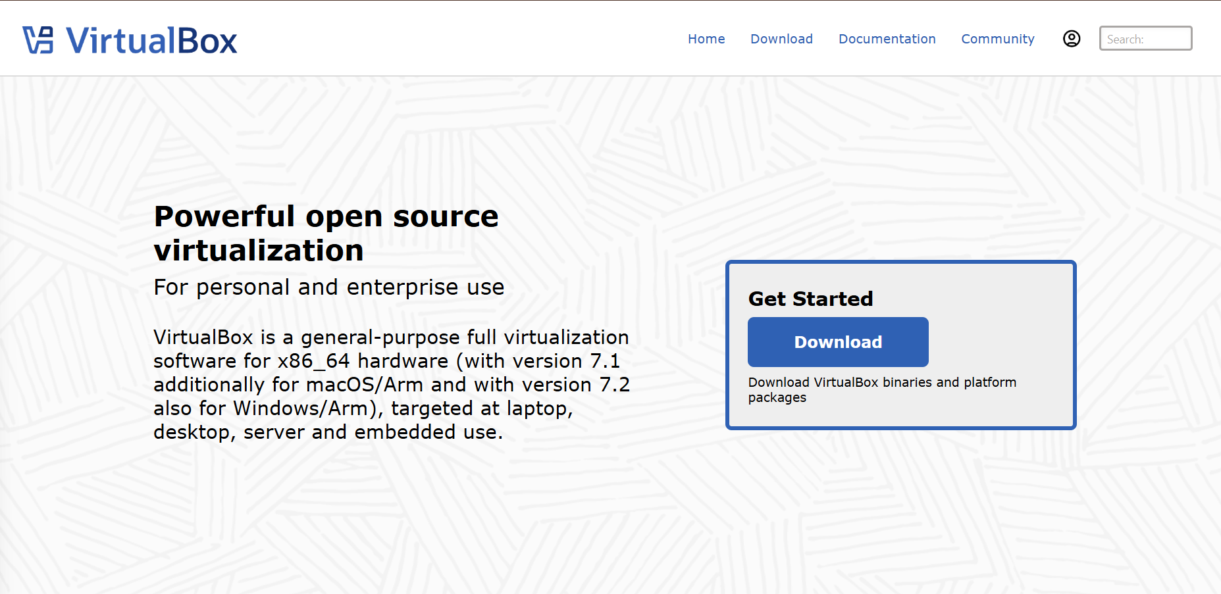
Proceeded to download the Windows Server 2022 from the official Microsoft website.
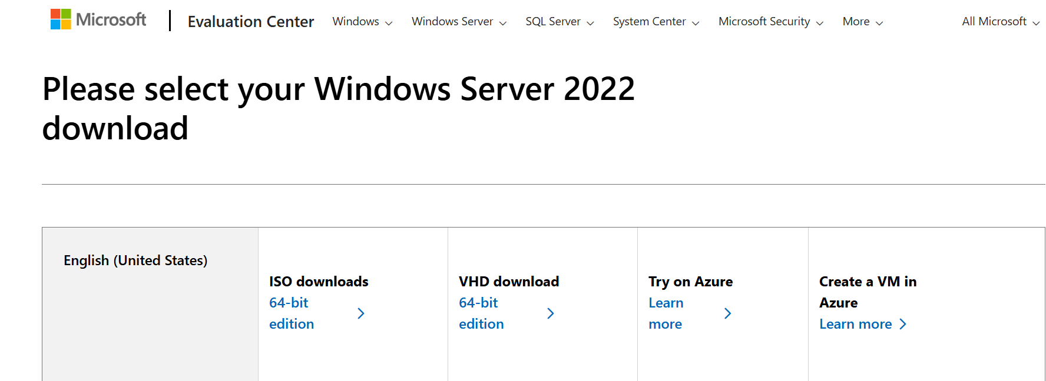

Continued to set up the VM, however it kept throwing an error whenever I would finish and try to run the VM.
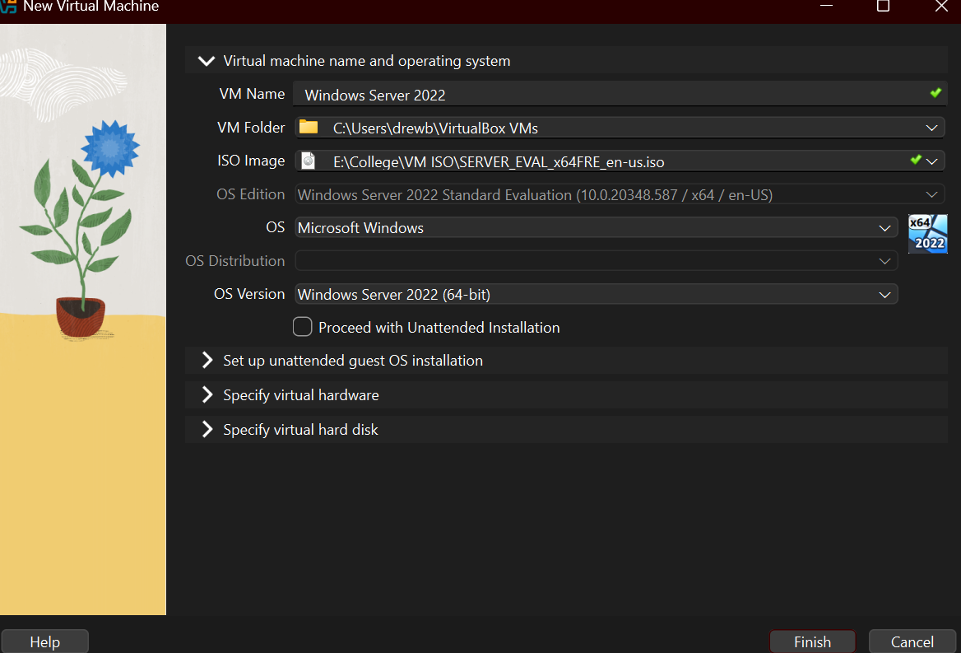
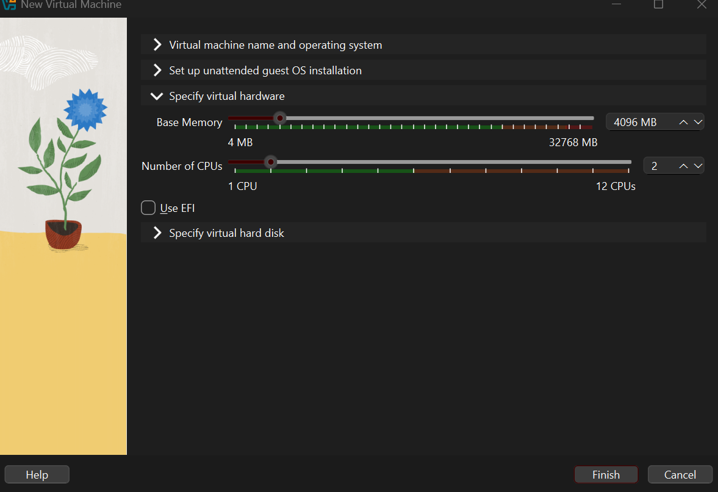
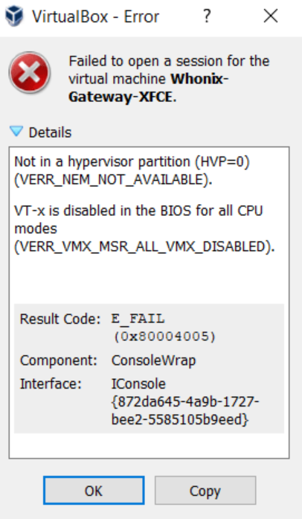
To fix this problem, first I went into Task Manager then to the Performance tab. In the CPU section I saw that Virtualization was disabled.
To turn it on, I had to restart my PC and mash the F11 key repeatedly to get into the BIOS. Once there, I enabled SVM Mode, which turned on virtualization so I could run my VM.
With SVM Mode enabled, my virtual machine now starts up normally without auto-aborting anymore.
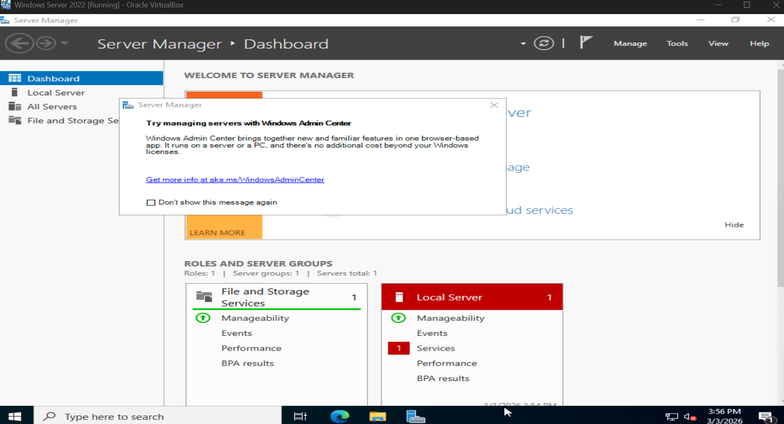
The purpose of this VM that I was setting up was to allow me to practice, configure, and fix common help desk problems.

